Amazon Web Services

**Relational Database Service**

# Relational Database Service - RDS

* Amazon RDS supports an array of database engines to store and organize data. It also helps with relational database management tasks, such as data migration, backup, recovery, and patching.

## Advantage of RDS

* Automatic Backups
* Multi-Availability Zone
* Read Replica

# RDS - Backup

* Backup refers to the copying of physical or databases to a secondary location for preservation in case of equipment failure.

## Types of Backups

* Automatic Backup
* Manual Backup
* Automatic backup is a type of data backup model that requires little or no human intervention in backing up and storing data from a local network/system to a backup facility.
* Automating the backup process saves the time and complexity required to manually back up a computer, network, or IT environment.
* Automatic backup allows us to recover our database at any point in time within a retention period. The retention period can be between 1 and 35 days.
* Default Retention Period is 7 Days
* Automatic backups will take a full daily snapshot and will also store transaction logs throughout the day. When we do a recovery, AWS will first choose the most recent daily backup, and then apply transaction logs relevant to that day.
* After they are deleted, the automated backups can't be recovered.
* Automatic backups are enabled by default
* **Automated backups rule:**
* Our DB instance must be in the AVAILABLE state for automated backups to occur. Automated backups don't occur while your DB instance is in a state other than AVAILABLE, for example, STORAGE_FULL.
* **Manual Backup**
* Manual Backup is also called Snapshot.
* Database Snapshots are done manually. They are stored even after we delete the original RDS instance, unlike automatic backups.
* We can have up to 100 manual snapshots per Region.

# RDS – Multi-Availability Zone

* Multi AZ allows us to have an exact copy of our production database in another AZ. AWS handles the replication for us. When our production database is written to, this write will automatically be synchronized to the standby database.
* In the event of planned database maintenance, database instance failure or an Availability zone failure, Amazon RDS will automatically failover to the standby so that database operations can resume quickly without administrative intervention.
* Both Database Servers have the same DNS endpoints

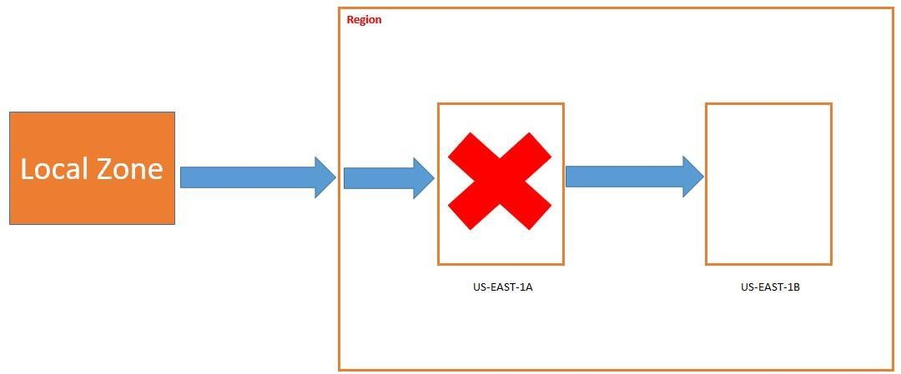

# RDS – Read Replica

* Read replica allows us to have a read-only copy of our production database.
* Amazon RDS Read Replicas provide enhanced performance and durability for RDS database (DB) instances.
* They make it easy to elastically scale out beyond the capacity constraints of a single

DB instance for read-heavy database workloads.

* We can have up to 5 read replica copies of any database.
* We can have read replicas of read replicas (But Latency will be there)
* When we create a read replica, RDS gives us a read-only endpoint which is a DNS that resolves only to our read replica.
* 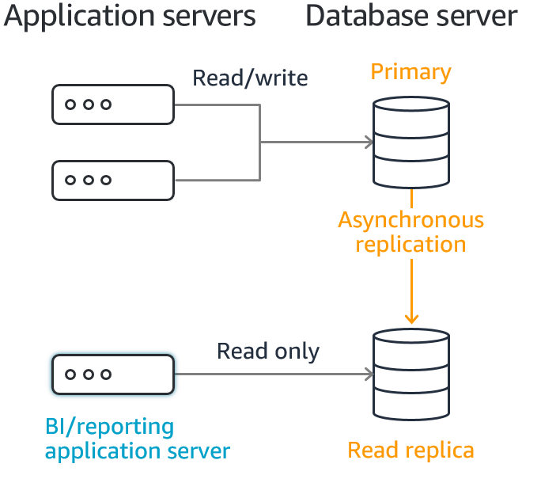A read replica and the master may be in different availability zones, and even in different regions.

# RDS – Read Replica VS Multi-AZ

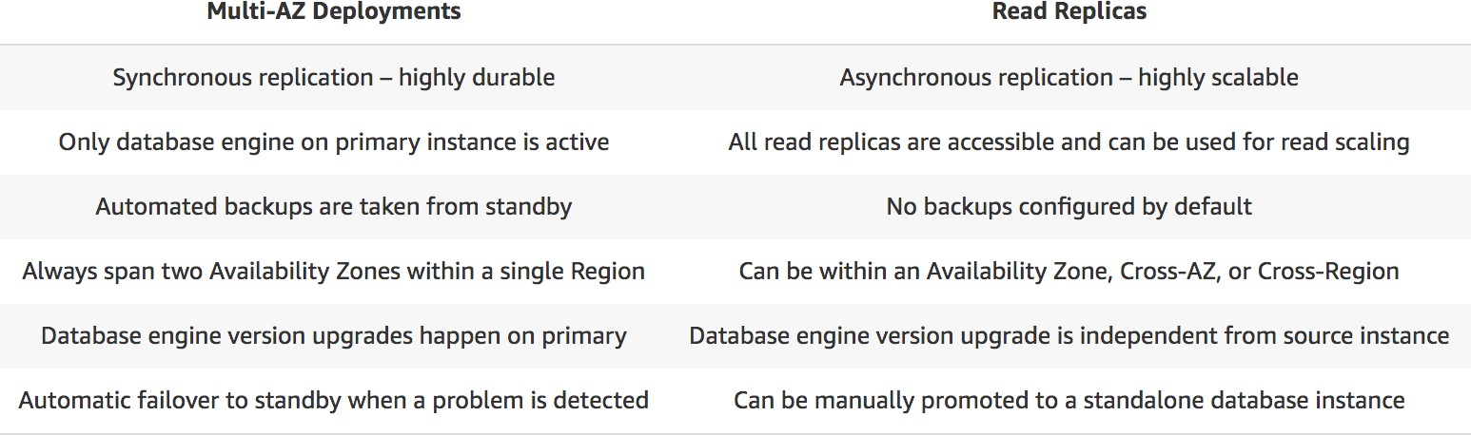

RDS

* Click on RDS
* Click on Create database
* Select standard create as the database creation method
* Select MySQL (It is open source database & it is given as free trial)
* Select the free tier
* Enter the database name
* Enter Master password & confirm password

# RDS

* Database instance class
* Go to Storage
* Go to Availability & Durability
* Go to Connectivity
* Select default VPC & Select default subnet group
* Select Yes for Public Access

# RDS

* Select Create new for Security group & enter the name for security group
* Select availability Zone
* Click on Additional Configuration
* Automatic Backup
* Click on Create database

# RDS – Connect with Workbench

* Download MYSQL Workbench: https://dev.mysql.com/downloads/workbench/
* Click on Database identifier
* Note down the endpoint & port number
* Open MySQL Workbench
* Click on Database
* Click on Connect to database

# RDS – Connect with Workbench

* Enter hostname
* Enter username (admin)
* Click on store in vault
* Enter password
* Click on ok
* SQL Query:

# RDS – Create Read Replica

Actions

Create Read Replica

* Click on create read replica
* System will create

# RDS – Manual Snapshot

Actions

Take Snapshot

* Click on take snapshot
* **Note: While practice don’t click on take snapshot**

**otherwise we will start getting bill.**

# RDS – Restore Snapshot

Select the snapshot

Actions

Restore snapshot

## Restore Backup

* Click on Automatic Backup

Select the Backup

Actions

Restore to point in

time

# RDS – Enable Multi Availability Zone

* Select the instance
* Click on Modify
* Go to Availability & Durability
* Select create a standby instance

# RDS – Delete the Database

* Select the Instance

Actions

Delete

* Uncheck create final snapshot
* Acknowledge the deletion
* Enter delete me
* Click on Delete